Lesson #8.3  Lesson Title:  _______________  _______________  Questions/Main Ideas: | Name _________________________________  Date _________________________ Hr ______  Temple - Notebook Page #________  Notes:
Triangle Similarity:
With most polygons, in order to prove __________________________, we must check EVERY pair of corresponding __________________________ to see if they are __________________________ and EVERY pair of corresponding __________________________ to see if they are __________________________…

However, if we are dealing with triangles, we have 3 shortcuts we can use

AA (Angle-Angle) Similarity:
If _____________________ ______________________of one triangle are __________________________ to _____________________ ______________________ of another triangle, then the triangles are __________________________.  For the triangles at the right:  - Why are they similar? _____________________________  - Give a similarity statement: __________ ~ ____________ | 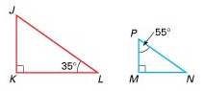

SSS (Side-Side-Side) Similarity:
If the _____________________ ______________________of one triangle are __________________________ to the _____________________ ______________________ of another triangle, then the triangles are __________________________.  For the triangles at the right:  - Why are they similar? _____________________________  - Give a similarity statement: __________ ~ ____________ | 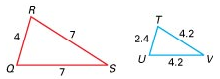

SAS (Side-Angle-Side) Similarity:
If _____________________ ______________________of one triangle are __________________________ to _____________________ ______________________ of another triangle and their ______________________ ______________________ are ______________________, then the triangles are __________________________.  For the triangles at the right:  - Why are they similar? _____________________________  - Give a similarity statement: __________ ~ ____________ | 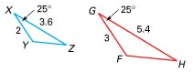

Your Turn!!
1. Are the triangles similar? Yes No  If yes, why? _____________  _________ ~ _________  If no, why not? ___________  ________________________ | 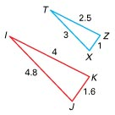

.Questions/Main Ideas: | Notes:
Your Turn!!
2. Are the triangles similar? Yes No
If yes, why? _____________
_________ ~ _________
If no, why not? ___________
________________________

3. Are the triangles similar? Yes No  If yes, why? _____________  _________ ~ _________  If no, why not? ___________  ________________________ | 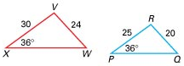

Your Turn!!
The triangles at the right are similar – how do you know? _____________

Similarity statement: _________ ~ _________

Find x:

Your Turn!!
Josh wanted to measure the height of the Sears Tower in Chicago. He used a 12-foot light pole and measured its shadow at 1pm. The length of the shadow was 2 feet. Then he measured the length of the Sears Tower’s shadow and it was 242 feet at the time. What is the height of the Sears Tower?

Summary – Write 3-4 sentences meant to summarize today’s lesson:

